**CTP Proposal –** Matt **Filer (17021871)**

A toolkit to produce inexpensive and realistic skyboxes for games

# Image result for horizon zero dawn skyboxIntro

Over recent years with advances in real-time rendering technologies and hardware capabilities, development studios have started to spend more and more of their graphics budgets on creating realistic skies. Most studios produce their own in-house systems at a large cost and impact to development time.

This project proposes an engine agnostic toolkit which can produce realistic skies through machine learning, with full control over the sky’s nature – from cloud density to sun position.

Figure 1: The sun sets in Horizon Zero Dawn.

To achieve this proposal, the project will stray away from the industry’s direction of often expensive and complex real-time rendered clouds and instead produce pre-rendered skies. These offline renders will be able to be utilised in any engine as a skybox model with associated material giving the benefit of a realistic sky with no noticeable impact on time to render at runtime, unlike most existing real-time solutions – as detailed in the research section. The tool will also produce an associated cubemap with the skybox for accurate environment image based lighting systems, or world reflections.

The result of the project will be a deliverable of a standalone executable, being the toolkit itself, which is intended to be created in a mixture of Python (utilising Google’s Tensorflow library) and C# (using WPF and/or Windows Forms).

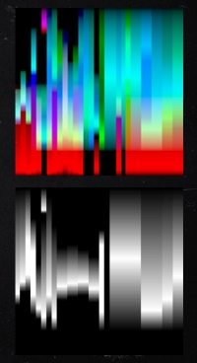A stretch goal for the project to increase the believability of the tool’s generated clouds is to support offline volumetric raymarching. This would involve performing 3D calculations based on the sun’s given position in a scene to work out light bounces within the generated cloud formations.

Figure 2 RDR2's height LUT.

# Research

As detailed by Bauer (2019), the skies in Red Dead Redemption 2 are achieved by utilising a cloud dome covering the entire world which is modulated by a series of noise maps such as Perlin, with height applied via textures that are selected from lookup tables filtered by current weather data. This method requires its own render pass. The lighting of the clouds is calculated with a mix of raymarching and volumetrics (the latter only occurring on clouds close to the player due to the high render time).

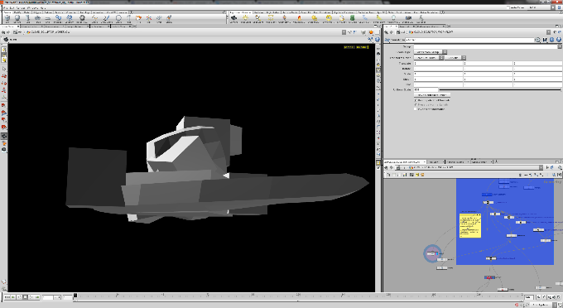In an interesting talk detailing failures in the process of creating Horizon Zero Dawn’s sky, Schneider (2015/17) explained several methods they tried and scrapped. While most were scrapped due to an expensive render time - for example, a method of modulating polygons using a 3D texture baked in Houdini, others were scrapped due to the barrier of entry it presented to the art department - for example, a fluid solver which produced cloud models when given basic shapes.

Figure 3 Horizon Zero Dawn's early prototype cloud meshes.

This issue of a technique being too expensive or out-of-scope for the art department is a common flaw with the increasing complexity of cloud rendering technologies, and something that this project aims to solve. Through a simple UI the intended sky will be produced as a single asset, able to be imported immediately into any engine with very little technical knowledge required – in theory, perfect for getting the right art direction, and perfect for maintaining the best performance.

Utilising machine learning to produce clouds for a skybox is a method that has been largely untested before, with major advances in machine learning technology only happening over the past few years. In conducting research for this project, only one vaguely similar creation could be found: a cloud detection algorithm called RS-Net (Remote Sensing Network), which was utilised for categorising satellite imagery (Jeppesen *et al*, 2019).

While the Tensorflow library has been identified for this project, a number of smaller libraries linked to Tensorflow may be utilised along the way to improve on its stock feature set.

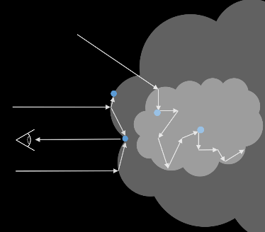Some research has been performed into the stretch goal of volumetric raymarching – a technique mainly saved for use in films due to the length of time to perform the calculation. Significant work has been done by the likes of Disney and Pixar (Schneider, 2011), with Disney recently releasing a large data set for a cloud produced in their own toolchain based on a photograph (Thacker, 2018).

This raymarching links heavily with the science behind light transport in clouds as explored by Satilmis (2016), where light does not simply enter and exit the clsoud, it bounces in chaotic formations which can lead to darker edges in their appearance (see figure 4). This bouncing is relative to the cloud’s water content, the size of the droplets within it, and neighbouring clouds, thus making their rendering tricky.

Figure 4 Cloud light bounce diagram.

# Project Objectives

* To source and/or capture enough required cloud data and process it in order to train a neural network that can accurately reproduce given cloud formations.
* To create a toolkit capable of producing realistic skyboxes and cubemaps given a set of user defined parameters, such as time of day and cloud density.
* To have the tool be a worthy rival of real-time techniques, despite its inability to perform day/night cycles at runtime.
* To keep the tool performant even for offline use, potentially allowing for previews from the user’s input before producing the final output.

# Research Objectives

* To research into existing methods to understand where both film and game industries are currently at, potentially interviewing a couple of key players in the field.
* To research machine learning methods to find the appropriate one to utilise for the project, being that it has largely not been attempted before.
* To research the best way to capture or source the data required to train the network.
* To research into the properties that users would like to control for the final image (user testing).

# Learning Objectives

* To learn how to utilise machine learning, and gain an understanding of its pros and cons.
* [If the stretch goal is reached] To learn more about volumetric raymarching, and how best it is achieved.
* To understand the patterns that make up the formation of the sky, and the levels at which clouds form.
* To understand Python, Tensorflow, and to create a tool that is considerate of its intended user base and allows for a friendly user experience.

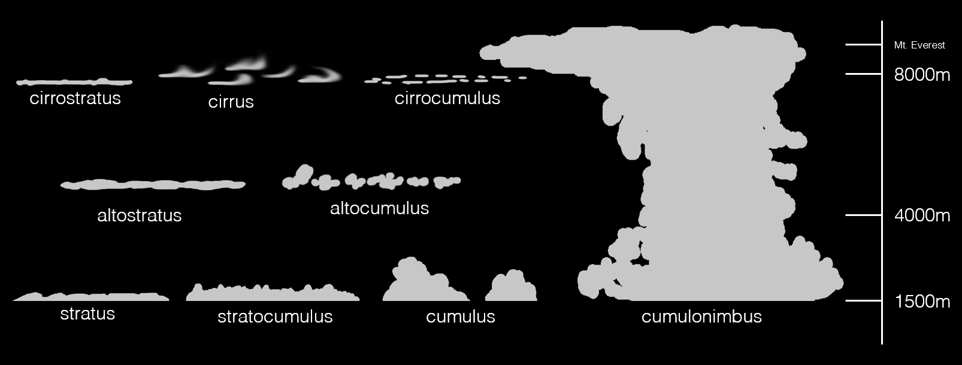

Figure 5 Cloud formations and their heights.

# Methods, Techniques, Tools, and Processes

The toolkit itself will rely on the utilisation of deep learning for the creation of its skies, with the initial intention being a creation based on a conditional GAN learned from a large set of captured cloud data. This will be carried out in Python using Google’s Tensorflow, and some other associated libraries.

Cloud data will be captured or sourced and the deep learning program will be given time to train on it. Once trained the conditional GAN should have resources for each type of cloud formation and be confident in reproducing a cloud of any given type in a range of lighting conditions. The user will be able to specify properties for time of day, cloud density, and potentially others if identified through user testing.

As an extension task the toolkit will utilise extra captured or sourced data to understand the 3D makeup of a cloud, allowing for volumetric calculations to be undertaken during the render, producing more realistic clouds dependant on the current sun position. To do this, cloud depth data would need to be calculated and volumetric raymarching performed on the 3D cloud structure, allowing for light to be simulated bouncing inside of its surface. This would allow for a realistic representation of the cloud at the current time of day selected by the user.

For project management a combination of GitHub issues and Trello will be used in conjunction with regular milestones to hit, as if working for a client. This method of incremental development to reach targets by specific dates is common in industry and works well to keep a project on track and focussed on the end goal (Victorino, 2016). I will also keep a progress log.

# Risks and Issues

|  |  |  |
| --- | --- | --- |
| Risk | Mitigation | Contingency |
| Lack of source data | Capturing enough data from varying locations | Finding alternate resources online |
| Clouds do not suit the lighting conditions | Capturing data at varying times of day | Targeting for a stretch goal of volumetric lighting |
| Tool is not user friendly or does not provide enough options | Perform user experience (UX) tests during development | Allow multiple preferences and accessibility options |

# Specialist Resources and Support Required

* Access to Tensorflow and the appropriate Python version and install environment.
* Access to source either existing cloud data (potentially a paid resource), or alternatively access to equipment that would allow the capture of such.

# References

* Bauer, F. (2019) *Creating the atmospheric world of Red Dead Redemption 2* [SIGGRAPH 2019], Los Angeles. 28 July.
* Jeppesen, J *et al.* (2019, p.247-259) *Remote Sensing of Environment.* Volume 229. Aarhus University, Denmark.
* Quilez, I (2010) Dynamic Clouds. *Iquilezles* [blog]. Available from: <http://www.iquilezles.org/www/articles/dynclouds/dynclouds.htm> [Accessed 27 September 2019]
* Satilmis, P (2016) *High Fidelity Sky Models* Thesis, University of Warwick.
* Schneider, A (2011) *Clouds in the skies of Rio* [SIGGRAPH 2011], Vancouver. 7 August.
* Schneider, A (2015) *The realtime volumetric cloudscapes of Horizon Zero Dawn* [SIGGRAPH 2015], Los Angeles. 13 August.
* Schneider, A (2017) *Authoring realtime volumetric cloudscapes with the Decima Engine* [SIGGRAPH 2017], Los Angeles. 30 July.
* Thacker, J (2018) Download Disney’s data set for Motunui island from Moana. *CG Channel* [blog]. 4July. Available from: <http://www.cgchannel.com/2018/07/download-disneys-data-set-for-motunui-island-from-moana/> [Accessed 28 September 2019]
* Victorino, L (2016) How to follow the five major milestones of game development *I make games for food* [blog]. 5 August. Available from: <http://lvictorino.com/blog/five-gates-gamedev.html> [Accessed 8 October 2019]

# Monthly Project Plan

|  |  |
| --- | --- |
| October | Final proposal to be submitted by 10th  Begin searching for sources and capturing sky data |
| November | Continued capturing of sky data  Begin work on neural network and early training |
| December | Using captured sky data for training  Begin testing outputs and required user inputs |
| January | Continued refining of training  Begin work on volumetrics |
| February | Continued work on volumetrics  Potential additional data capture |
| March | Polishing volumetric implementation  Potential look into additional extension of real time ability  Begin draft of write-up / potential interviews |
| April | Final polish and user testing  Finish write-up  Final hand-in 23rd |



Faculty of Environment & Technology

Faculty Research Ethics Committee (FREC)

**Ethical Review Checklist for Undergraduate and Postgraduate Modules**

*Please provide project details and complete the checklist below.*

**Project Details:**

|  |  |
| --- | --- |
| **Module name** | **Creative Technologies Project** |
| **Module code** | **UFCFS4-30-3** |
| **Module leader** | Michaela Palmer |
| **Project Supervisor** | **Tom Bashford-Rogers** |
| **Proposed project title** | **A toolkit to produce inexpensive and realistic skyboxes for games** |

**Applicant Details:**

|  |  |
| --- | --- |
| **Name of Student** | Matthew Filer |
| **Student Number** | 17021871 |
| **Student’s email address** | matthew2.filer@live.uwe.ac.uk |

| **CHECKLIST QUESTIONS** | | **Yes/No** | **Explanation** |
| --- | --- | --- | --- |
|  | Does the proposed project involve **human tissue,** **human participants, animals, environmental damage, or the NHS.** | No | *If the answer to this is ‘No’ then no further checks in the list need to be considered.* |
|  | Will participants be clearly asked to give consent to take part in the research and informed about how data collected in the research will be used? |  |  |
|  | If they choose, can a participant withdraw at any time (prior to a point of “no return” in the use of their data)? Are they told this? |  |  |
|  | Are measures in place to provide confidentiality for participants and ensure secure management and disposal of data collected from them? |  |  |
|  | Does the study involve people who are particularly vulnerable or unable to give informed consent (eg, children or people with learning difficulties)? |  |  |
|  | Could your research cause stress, physical or psychological harm to humans or animals, or environmental damage? |  |  |
|  | Could any aspects of the research lead to unethical behaviour by participants or researchers (eg, invasion of privacy, deceit, coercion, fraud, abuse)? |  |  |
|  | Does the research involve the NHS or collection or storage of human tissue (includes anything containing human cells, such as saliva and urine)? |  |  |

Your explanations should indicate briefly for Qs 2-4 how these requirements will be met, and for Qs 5-8 what the pertinent concerns are.

* **Minimal Risk:** If **Q 1 is answered ‘No’**, then no ethics approval is needed.
* **Low Risk:** If **Qs 2-4 are answered ‘Yes’ and** **Qs 5-8 are answered ‘No’**, then no approval is needed from the *Faculty Research Ethics Committee* (FREC). However, your supervisor must approve (a) your information and consent forms (Qs 2 & 3) and (b) your measures for participant confidentiality and secure data management (Q4).
* **High Risk:** If **any of Qs 5-8 are answered ‘Yes’**, then you must submit an application for full ethics approval *before* the project can start.This can take up to 6 weeks. Consult your supervisor about how to apply for full ethics approval.

**Risk Assessment:** Separate guidance on risk assessment can be found on UWE’s Health and Safety forms webpage at <https://go.uwe.ac.uk/RiskAssessment>. If needed, you must complete a Risk Assessment form. This must also be attached to your application for full ethics approval if your project is **High Risk**.

|  |
| --- |
| **Your supervisor must check your responses above *before* you submit this form.** |
| **Submit this completed form via the *Assignments* area in Blackboard (or elsewhere if so directed by the module leader or your supervisor)***.* |
| After you have uploaded this form, your supervisor will confirm it has been correctly completed by “marking” it as *Passed*/100% via the *My Grades* link on the Blackboard*.* |

Further research ethics guidance is available at <http://www1.uwe.ac.uk/research/researchethics>